1/18/2021

Agha Danial Durrani

Virtual University of Pakistan

E-CART

E-Commerce Web Application

**Final Project Report**

**<<E-Cart>>**



**Project Supervisor**

<<Maham Murtaza Khan>>

**Submitted By**

<<S20022F785>>

<<Agha Danial Durrani>> <<MC190204516>>

**Software Projects & Research Section,**

**Department of Computer Sciences,**

**Virtual University of Pakistan**

|  |
| --- |
|  |



**CERTIFICATE**

This is to certify that <<Agha Danial Durrani>> (<<MC190204516>>), had worked on and completed his Software Project at Software & Research Projects Section, Department of Computer Sciences, Virtual University of Pakistan in partial fulfillment of the requirement for the degree of MSc in Computer Sciences under my guidance and supervision.

In our opinion, it is satisfactory and up to the mark and therefore fulfills the requirements of MSc in Computer Sciences.

**Supervisor / Internal Examiner**

<<Maham Murtaza Khan>>

Supervisor,

Software Projects & Research Section,

Department of Computer Sciences

Virtual University of Pakistan

___________________

(Signature)

**External Examiner/Subject Specialist**

<<Neelam Alam>>

Subject Specialist,

Department of Computer Sciences

Virtual University of Pakistan

___________________

(Signature)

**Accepted by:**

**_____________**

(For office use)

**EXORDIUM**

**In the name of ALLAH, the Most Gracious, the Most Merciful**

**All Praise is for Allah, Lord of all worlds**

**The Most Compassionate, the Most Merciful**

**Master of the Day of Judgment**

**You alone we worship, and**

**You alone we ask for help**

**Guide us along the Straight Path**

**The Path of those You have blessed,**

**not those You are displeased with,**

**or those who are astray.**

**DEDICATION**

**To ALLAH Almighty**

**My elder brother Shaheed Agha Waqas Khan Durrani (Software Engr. UET Lahore)**

**My Parents & Teachers**

**Who taught me that it is never too late to change careers to pursue your true passion.**

**ACKNOWLEDGEMENT**

I would like to express my special thanks of gratitude to my project Supervisor **“Maham Murtaza Khan”** for their able guidance and support in completing my project.

**Agha Danial Durrani**

M.Sc (Computer Science)

Virtual University

**PREFACE**

The project has been made by my own effort and with the support of Supervisor. This project E-Cart is a web based application.

**TABLE OF CONTENTS**

|  |
| --- |
|  |

CHAPTER NO. 1

gathering & Analyzing info 10

1.1 Introduction 11

1.2 purpose 11

1.3 scope 11

1.4 Project requirements 12

1.4.1 Functional Requirements

1.4.2 Non-Functional Requirements

1.5 use cases and usage scenarios 14

1.5.1 Use Case Diagrams

1.5.2 Usage Scenarios

1.6 Development Methodology 20

1.6.1 Chosen Methodology

1.6.2 Reasons for Chosen Methodology

1.6.3 Work Plan (Gantt Chart). Project Schedule (Submission Calendar)

CHAPTER NO. 2

designing the project 22

2.1 Introduction 23

2.2 purpose 23

2.3 scope 23

2.4 Architectural Representation (Architecture Diagram) 24

2.5 Dynamic Model: Sequence Diagrams 25

2.6 Object Model/Logical Model: Class Diagram 27

2.7 Database Model (Database Diagram) 28

2.8 Graphical User Interfaces 29

Chapter no.3

DEvelopment 31

3.1 Development plan (Architecture Diagram) 32

**CHAPTER 1**

Gathering & Analyzing Info

**Gathering & Analyzing Info**

# **1.1 Introduction of Project:**

E-Cart is a multi-vendor web application (app) for sales and purchase of any type of food item online.

**History of online shopping**

One of the earliest forms of trade conducted online was IBM's online transaction processing (OLTP) developed in the 1960s and it allowed the processing of financial transactions in real-time. The computerized ticket reservation system developed for American Airlines called Semi-Automatic Business Research Environment (SABRE) was one of its applications. Here, computer terminals located in different travel agencies were linked to a large IBM mainframe computer, which processed transactions simultaneously and coordinated them so that all travel agents had access to the same information at the same time

The first World Wide Web server and browser, created by Tim Berners-Lee in 1989, opened for commercial use in 1991.

1.2 purpose

I choose the E-Cart project because I have interested to develop such a program. And one other reason for choosing this project is that today the whole world is fighting with COVID-19, people are bounded in their homes. Nobody wants to go outside for shopping due to a pandemic situation.

1.3 scope

The Software system being produced is called E-Cart. It is being produced for two categories of people. 1st are sellers who want to sell their products and 2nd are customers who want to buy something via the internet. This software system gives an advantage to the seller to categorize their products by which customer can easily approach their desire thing.

This Software system allows any seller to create their account on this system by approval of an admin. After signing Up seller can categorize their products for customers and he can add his bank account number for receiving payment of products via debit or credit card.

This software system also allows any user to browse products. User can be a customer by creating an account on the system. Customers can buy different items from different sellers, the bill of their purchased items from different stores shows separately. Customers have both options to pay their bills via credit/Debit card or pay on delivery.

1.4 Project requirements

At the highest level, every project has two types of requirements:

1.4.1 **Functional Requirements**

Functional requirements are product features or functions that developers must implement to enable users to accomplish their tasks. So, it's important to make them clear both for the development team and the stakeholders. Generally, functional requirements describe system behavior under specific conditions.

There are three modules in this application. For each we will describe functional requirements.

* + - 1. **Admin Module:**
* After login admin can make any other person as admin.
* Admin can allow any seller or customer
* Admin can block any seller or customer
* Admin can authenticate sign-up form of seller.
* Admin can view reports of any store on a daily, weekly, or monthly basis.
* Admin can view how many times a store is visited by customers or any user
* Admin can add or remove any customer
* On the behalf of feedback given by customer’s admin can give warning to sellers.
* Admin can logout.
* Admin will automatically logout if he remains inactive for 30 minutes.
  + - 1. **Seller Module:**
* the seller can sign up by providing his basic information about his store by filling a sign-up form and wait for approval from the admin.
* After authentication seller can make his store by adding his products
* Seller can categorize his products
* Seller can add/remove any product on the behalf of availability.
* Seller can add any other person as his partner/helper
* Seller can view, confirm, or cancel any order.
* Application will notify seller about limited stock.
* Seller can generate discount offer or coupon against any of his products.
* Seller can also add/delete any customer manually.
* Seller can logout.
* Seller will automatically logout if he remains inactive for 30 minutes.
  + - 1. **Customer Module:**
* Any user can view the products.
* Any user can be a customer by sign up on the application.
* Customer can put their favorites items on the wish list.
* Customers can add products by adding them to the cart while browsing.
* Customer can check-out and pay their bill via debit/credit card.
* Customer can also pay their bill on delivery.
* Customer can log-out.
* Customer can delete his account.
* Customer will automatically logout if he remains inactive for 30 minutes.
* Customers can give feedback against the product he bought.

**1.4.2** **Non-Functional Requirements**

Nonfunctional Requirements (NFRs) define system attributes such as security, reliability, performance, maintainability, scalability, and usability. They serve as constraints or restrictions on the design of the system across the different backlogs. ... They ensure the usability and effectiveness of the entire system.

Non-Functional requirements are:

* Availability
* Reliability
* Maintainability
* Security
* Regulatory
* Environmental
* Data integrity
* Usability
* Recoverability

1.5 use cases and usage scenarios

**1.5.1 Use Case Diagrams**

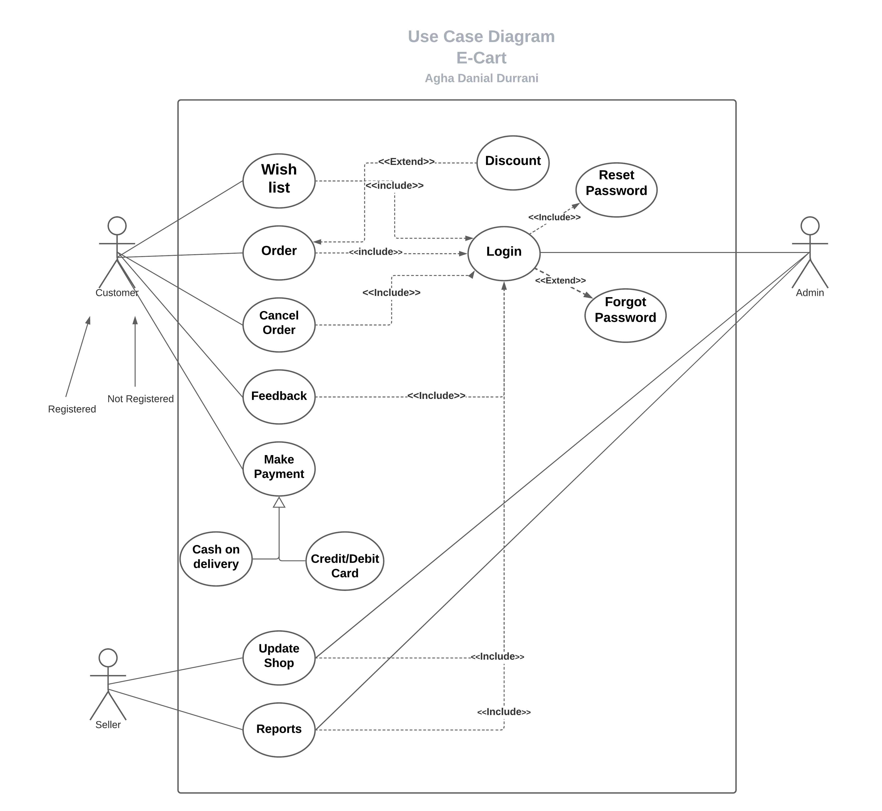

**1.5.2 Usage Scenarios**

|  |  |
| --- | --- |
| **Use case title** | Login |
| **Use case ID** | EC_User-1 |
| **Actions** | Enter user name  Enter password  Press login button |
| **Description** | After entering user name and password admin, seller or customer can be log-in |
| **Alternatives path** | N/A |
| **Pre-condition** | Account must be created |
| **Post condition** | User is now logged-in |
| **Author** | MC190204516 |
| **Exceptions** | Any user can visit store without logging-in. user can only browse stores. |

|  |  |
| --- | --- |
| **Use case title** | Sign-Up |
| **Use case ID** | EC_Seller-1 |
| **Actions** | Click sign-up as seller button  Put basic details in form  Create user name and password  Submit form |
| **Description** | User can open application and then click on sign-up as a seller button. A form will be opened. User will fill this form and create his user name and password and submit this form. After approval from admin he can be a seller. |
| **Alternatives path** | N/A |
| **Pre-condition** | User was not already register |
| **Post condition** | User will be able to login |
| **Author** | MC190204516 |
| **Exceptions** | Link is down or user already exists. |

|  |  |
| --- | --- |
| **Use case title** | Sign-Up |
| **Use case ID** | EC_Customer-1 |
| **Actions** | Click on sign-up button  Fill basic information  Create user name and password  Submit form |
| **Description** | User can open application and then click on sign-up button. A form will be opened, user will fill this form and create his user name and password by providing email address and then submit. Now customer login by verifying his account by email. |
| **Alternatives path** | N/A |
| **Pre-condition** | User was not register |
| **Post condition** | User can now login and can buy anything from any store |
| **Author** | MC190204516 |
| **Exceptions** | User can just visit stores without signing-up. User already exists. |

|  |  |
| --- | --- |
| **Use case title** | Allow/restrict any user |
| **Use case ID** | EC_Admin-22 |
| **Actions** | Admin will allow any user  Admin will restrict any user |
| **Description** | Admin have authority to allow any user or block any user to login |
| **Alternatives path** | Delete user accounts |
| **Pre-condition** | Admin must be log-in |
| **Post condition** | User cannot be able to login or perform tasks |
| **Author** | MC190204516 |
| **Exceptions** | Link is down |

|  |  |
| --- | --- |
| **Use case title** | Update Database |
| **Use case ID** | EC_Admin-33 |
| **Actions** | Admin will update contents on web application |
| **Description** | Admin will update contents on web application and categorize stores |
| **Alternatives path** | Manipulate contents |
| **Pre-condition** | Contents must be created |
| **Post condition** | New updated application |
| **Author** | MC190204516 |
| **Exceptions** | User has no access to update content or link is down |

|  |  |
| --- | --- |
| **Use case title** | View Report |
| **Use case ID** | EC_Admin-rep-1 |
| **Actions** | Admin will open click on report button  Now select duration  Click on view button |
| **Description** | Admin can view stats of web application. How many users visited or purchasing? |
| **Alternatives path** | N/A |
| **Pre-condition** | Admin should be logged-in. |
| **Post condition** | Report summary will be shown |
| **Author** | MC190204516 |
| **Exceptions** | Not any user visited so report will be empty |

|  |  |
| --- | --- |
| **Use case title** | Add/Remove Products |
| **Use case ID** | EC_SEL-1 |
| **Actions** | Click on adding items to store  Enter number of items adding in stock  Click on removing items from store  Remove number of items |
| **Description** | Seller can add/remove items on the behalf of availability of products |
| **Alternatives path** | Create or remove complete category of products |
| **Pre-condition** | Seller must be login |
| **Post condition** | New items are added in inventory or removed from inventory |
| **Author** | MC190204516 |
| **Exceptions** | Link is down or blocked from admin |

|  |  |
| --- | --- |
| **Use case title** | Confirm/Cancel Orders |
| **Use case ID** | EC_order-1 |
| **Actions** | Seller will confirm order  Seller will cancel order |
| **Description** | When any order is giving from customer to buy anything, seller can confirm his order or cancel his order |
| **Alternatives path** | Admin will confirm or cancel orders |
| **Pre-condition** | Customer must be order to buy anything from store |
| **Post condition** | Order must be confirmed or canceled for delivery. |
| **Author** | MC190204516 |
| **Exceptions** | Web Link is down, or order cannot found |

|  |  |
| --- | --- |
| **Use case title** | Generate discount Coupons |
| **Use case ID** | EC_Dis-1 |
| **Actions** | Seller will generate coupon/promo codes  User put these coupon number  Discount will be given on specific product |
| **Description** | Seller will generate some promo codes which are entered by customer can get discount. |
| **Alternatives path** | Getting discount by inviting friend |
| **Pre-condition** | Product must be in inventory |
| **Post condition** | Discount must be given on specific product |
| **Author** | MC190204516 |
| **Exceptions** | Promo code is expired |

|  |  |
| --- | --- |
| **Use case title** | Basic Search |
| **Use case ID** | EC_src-1 |
| **Actions** | Open web application  Browse stores |
| **Description** | Any user can browse stores by just opening web application |
| **Alternatives path** | Use URL of specific product |
| **Pre-condition** | Access to web application |
| **Post condition** | View products |
| **Author** | MC190204516 |
| **Exceptions** | User have no access to web application |

|  |  |
| --- | --- |
| **Use case title** | Wish List |
| **Use case ID** | EC_Cst-1 |
| **Actions** | Browse any product and then click add to wish list |
| **Description** | Customer can add anything to wish list by adding product to wish list, so he can buy this product any time. It is marked as his favorite item. |
| **Alternatives path** | Add to cart |
| **Pre-condition** | Must be logged-in |
| **Post condition** | Added item to his wish list to see this anytime. |
| **Author** | MC190204516 |
| **Exceptions** | User is not registered |

|  |  |
| --- | --- |
| **Use case title** | Items adding to cart |
| **Use case ID** | EC_buy-1 |
| **Actions** | Click on add to cart |
| **Description** | While browsing customer can add any product to cart to buy it, before checking out customer can confirm the order of his cart items. |
| **Alternatives path** | N/A |
| **Pre-condition** | User must be logged-in.  Stock is available |
| **Post condition** | Confirmed order |
| **Author** | MC190204516 |
| **Exceptions** | User is not registered or product is out of stock |

|  |  |
| --- | --- |
| **Use case title** | Pay Bill |
| **Use case ID** | EC_bill-1 |
| **Actions** | Click on pay bill.  Entering credit/debit card number  Enter CVN number given on the back side of credit/debit card.  Confirm pay.  Cash on delivery |
| **Description** | Before check out customer have two options for payment method. 1st is online payment via debit/credit card and 2nd is cash on delivery |
| **Alternatives path** | N/A |
| **Pre-condition** | Products must be in cart |
| **Post condition** | Order confirmed/ canceled |
| **Author** | MC190204516 |
| **Exceptions** | User is logged-out due to in-active for 30 minutes |

|  |  |
| --- | --- |
| **Use case title** | Feedback |
| **Use case ID** | EC_Custfb-1 |
| **Actions** | Click on feedback button  Fill form and give stars  Submit form |
| **Description** | Customer can give feedback for any store after buying products from there. |
| **Alternatives path** | N/A |
| **Pre-condition** | Buy anything from store |
| **Post condition** | Rated store |
| **Author** | MC190204516 |
| **Exceptions** | User does not buy anything or User is logged-out due to in-active for 30 minutes |

1.6 Development Methodology

**1.6.1 Chosen Methodology**

**VU Process Model:**

I will adopt the VU Process Model for this Project. The VU process model is a combination of waterfall and spiral models. The waterfall model is a sequential design process, in which every next phase of the project is started after completion of the previous phase whereas the spiral model is helpful to identifying major risks of both technical and managerial nature and how to avoid or minimize these risks to keep the software development process under control.

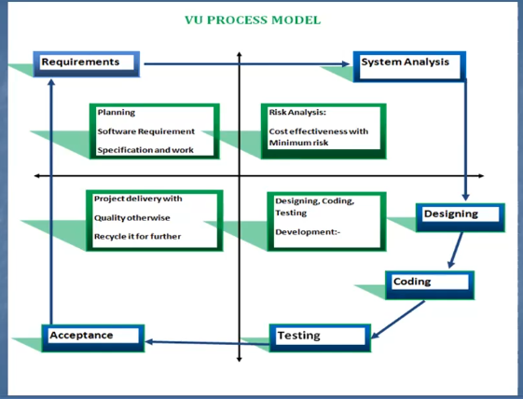

**1.6.2 Reasons for Chosen Methodology**

These are the reasons due to which the VU Process Model is preferred as a working methodology. These are listed below

* Due to no prior experience or expertise in such a software project. As it is easy to revert back to an earlier in the VU model.
* It also facilitates to take feedback from clients and integrate changes needed accordingly.
* It facilitates performing risk analysis effectively to eliminate losses that occur due to doubtful development models, resource requirements, project constraints, and time.
* The VU Process Model allows the addition of product elements at a later stage when they become available or recognized ensuring that there is no conflict between requirements and design.
* The VU Process Model facilitates early user involvement in the system development effort. The user's knowledge about the project rises as the project complete, so users can interface effectively with management.
* This method is consistent with methods that have multiple software builds and releases and allows for making an orderly transition to a maintenance activity
* The VU Process Model is suitable for projects with heavy user interfacing, such as Production Rejection Assessment System (PRAS).
* The VU Process Model provides the flexibility to implement changes in design at several stages of the project.
* The VU Process Model facilitates the constriction of large systems in easy small segments.

**1.6.2 Work Plan (Gantt Chart)**

A Gantt chart is used for planning projects of all sizes, and it is a useful way of showing what work is scheduled to be done on a specific day.

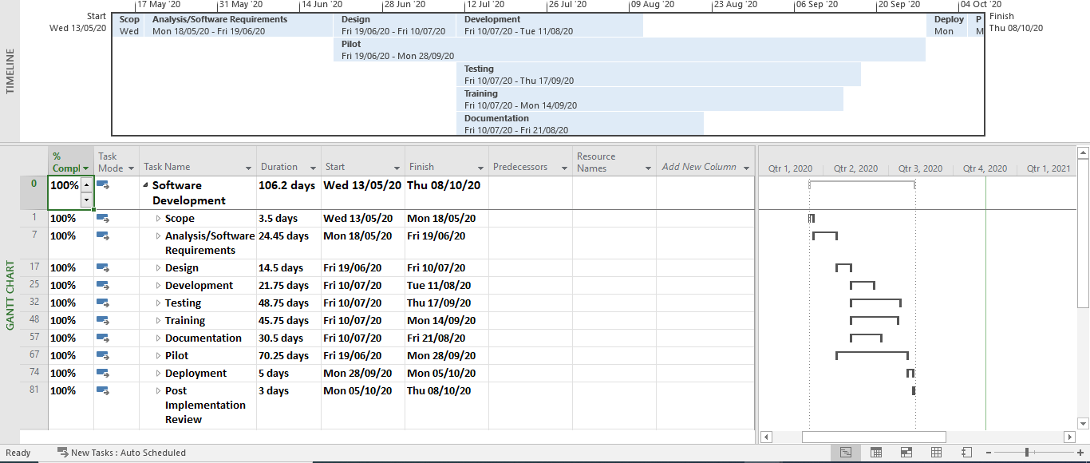

**CHAPTER 2**

Designing the Project

designing the project

2.1 Introduction

The analysis and design phase contains different design elements which explains the software project in sufficient details. The **Entity Relationship Diagram (ERD)** illustrate the logical structure of database, in this we define entities, their attributes and their relationship. The **Sequence diagram** `shows sequence of processes operating with one another. The **Architecture Design Diagram** is a graphical representation of a set of concepts, that are part of an architecture, including their principles, elements and components. The **Class Diagram** is the main building block of object-oriented modeling. It is used for general conceptual modeling of the structure of the application, and for detailed modeling translating the models into programming code. **Database design** is the organization of data according to a database model. The analysis and design phase is a very essential phase in a software project. The main objective of the project is to create an online shopping store that allows users to search and purchase products. The products are displayed in categorize form and the user can order their desire item online through credit/debit card payment or payment on delivery. The Administrator will have additional functionalities then compared to the common user.

2.2 purpose

The purpose of the Design Phase is to transmute the requirements into complete and detailed system design specifications. The purpose of the Software Design Document is to provide a description of the design of a system fully enough to allow for software development to proceed with an understanding of what is to be built and how it is expected to build. The Software Design Document provides information necessary to provide a description of the details for the software and system to be built.

2.3 scope

The Design Scope outlines the general aims and goals of the project design and lists the major deliverables and milestones.

2.4 Architectural Representation (Architecture Diagram)

An architectural diagram is a diagram of a system that is used to abstract the overall outline of the software system and the relationships, constraints, and boundaries between components.

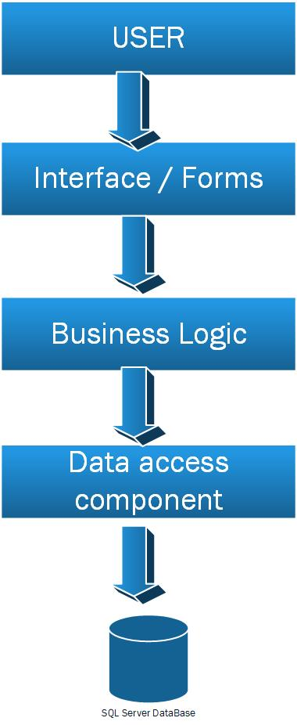

2.5 Dynamic Model: Sequence Diagrams

A sequence diagram shows object interactions arranged in time sequence. It depicts the objects involved in the scenario and the sequence of messages exchanged between the objects needed to carry out the functionality of the scenario.

**Diagrams**

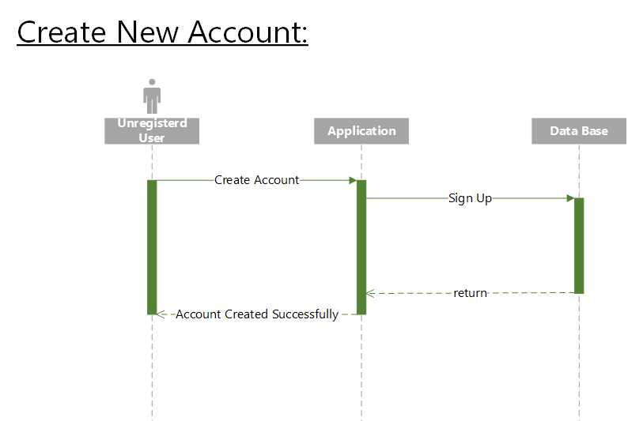

**Login User Admin:**

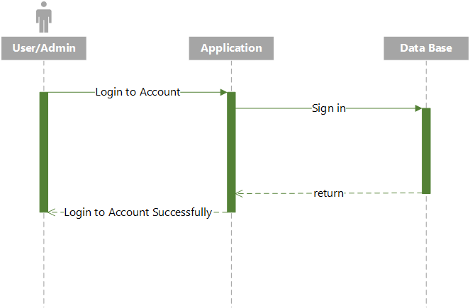

**Customer Order Confirmation:**

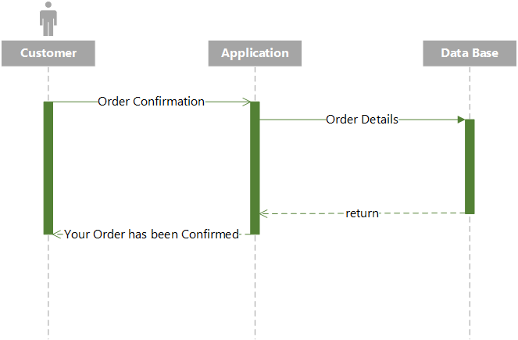

2.6 Object Model/Logical Model: Class Diagram

The class diagram is the main building block of object-oriented modeling. It is used for general conceptual modeling of the structure of the application, and for detailed modeling translating the models into programming code. Class diagrams can also be used for data modeling.

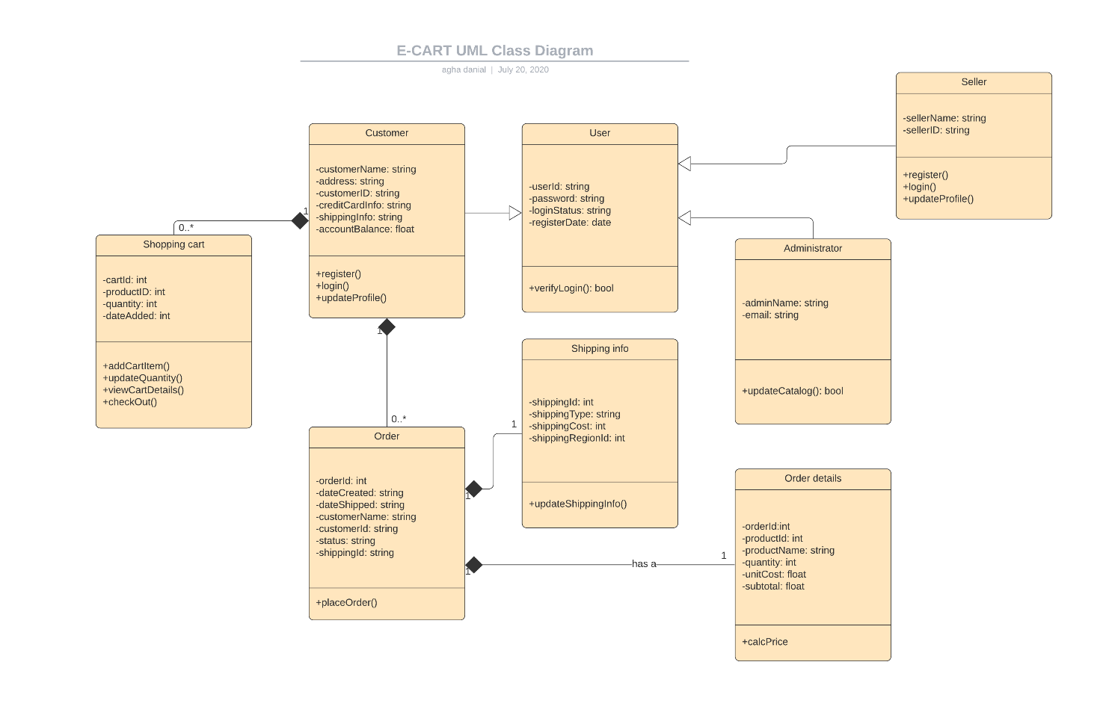

2.7 Database Model (Database Diagram)

The Data Modeling diagram is used to create or view graphical models of relational database system schemas including a range of database objects. The diagrams can be drawn at a logical or a physical level.

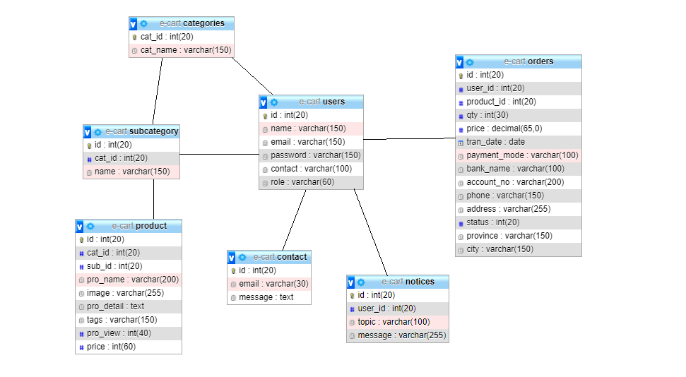

2.8 Graphical User Interfaces:

A GUI (graphical user interface) is a system of interactive visual components for computer software. A GUI displays objects that convey information, and represent actions that can be taken by the user. The objects change color, size, or visibility when the user interacts with them.

**GUI of Home Page**

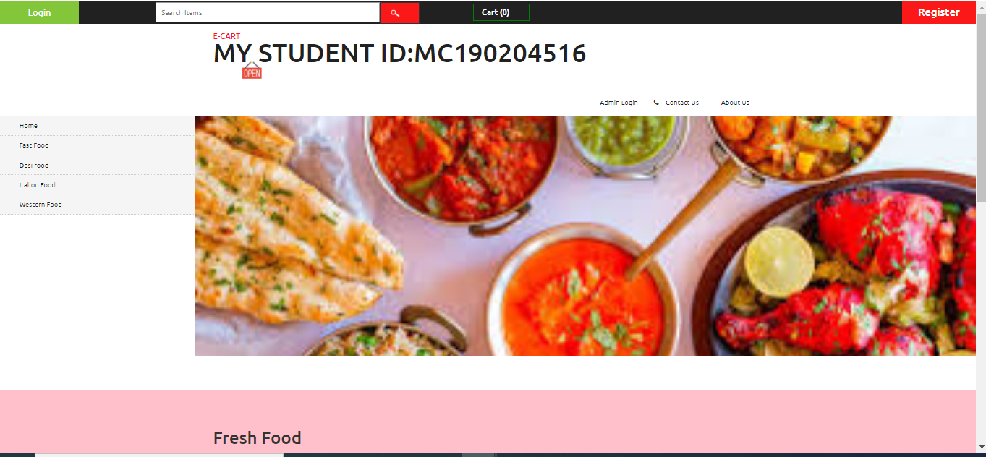

**GUI of Login Page**

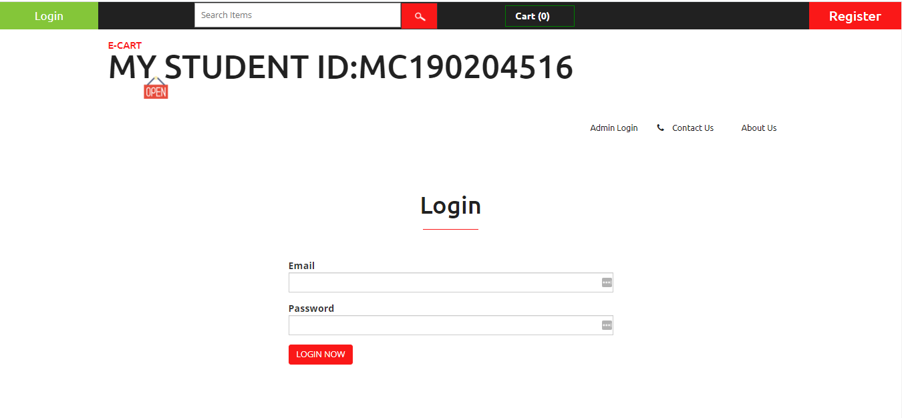

**GUI of Registration page**

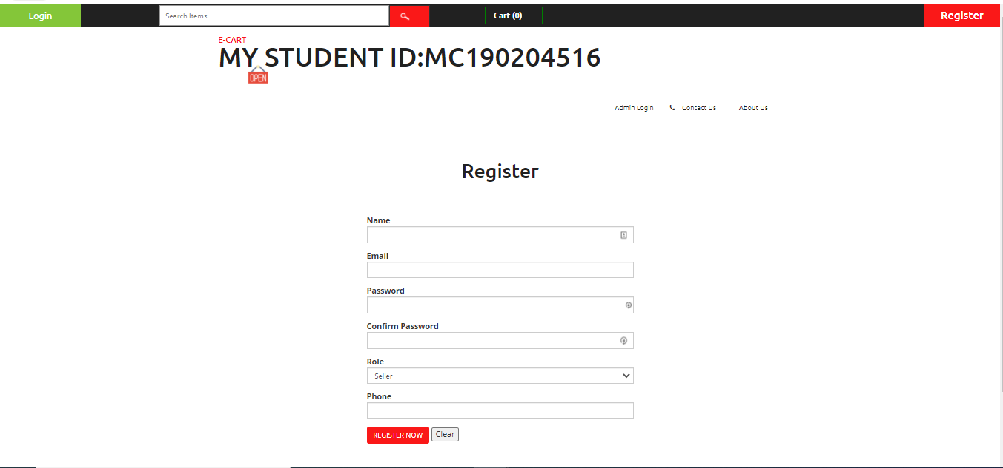

**CHAPTER 3**

Development

**3.1 Development plan (Architecture Diagram)**



**REFERENCES**

1. [www.google.com](http://www.google.com)

**APPENDIX**